|  |  |
| --- | --- |
| **­­­Exp No: 1**  **Date: 7.2.25** | **HTML AND CSS** |

**AIM:**

To create a web page that embeds a map with hotspots, frames, and links using embedded, external, and inline CSS

**PROGRAM:**

**Hotspot.html**

<html>

<head>

<title>Map with Hotspots</title>

</head>

<body>

<h2>Image Map Example</h2>

<img src="india map.jpg" alt="Map" usemap="#workmap" width="600" height="400">

<map name="workmap">

<area shape="rect" coords="34,44,270,350" alt="Location1" href="https://www.google.com">

<area shape="circle" coords="337,300,44" alt="Location2" href="https://www.yahoo.com">

</map>

<br>

<a href="https://en.wikipedia.org/wiki/Outline_of_India">Visit Example</a>

</body>

</html>

**Style.css**

@charset *"ISO-8859-1"*;

**body** {

font-family: *Arial,* *sans-serif*;

margin: *0*;

padding: *0*;

background-color: *#f4f4f4*;

}

**img** {

display: *block*;

margin: *0* *auto*;

border-radius: *8px*;

box-shadow: *0* *4px* *6px* *rgba(0,* *0,* *0,* *0.1)*;

}

/* Styling for the map areas */

**area** {

outline: *none*;

border: *none*;

transition: *transform* *0.3s* *ease-in-out*;

}

**area***:hover* {

transform: *scale(1.1)*;

}

**OUTPUT:**

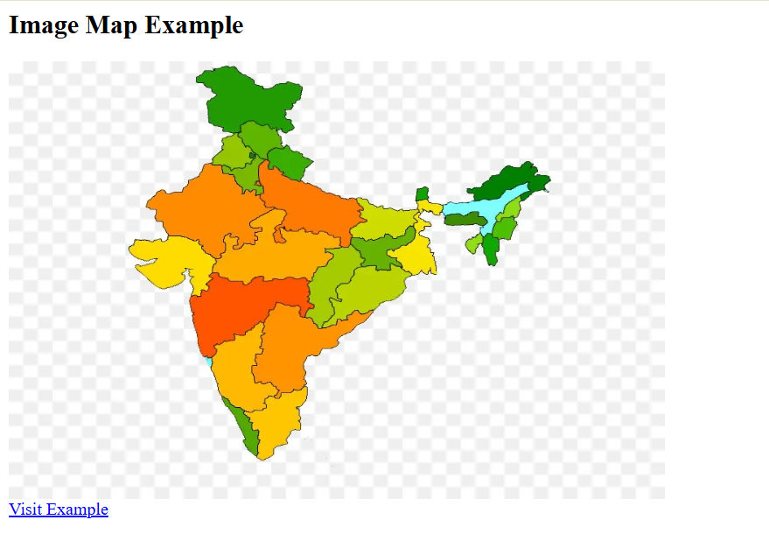

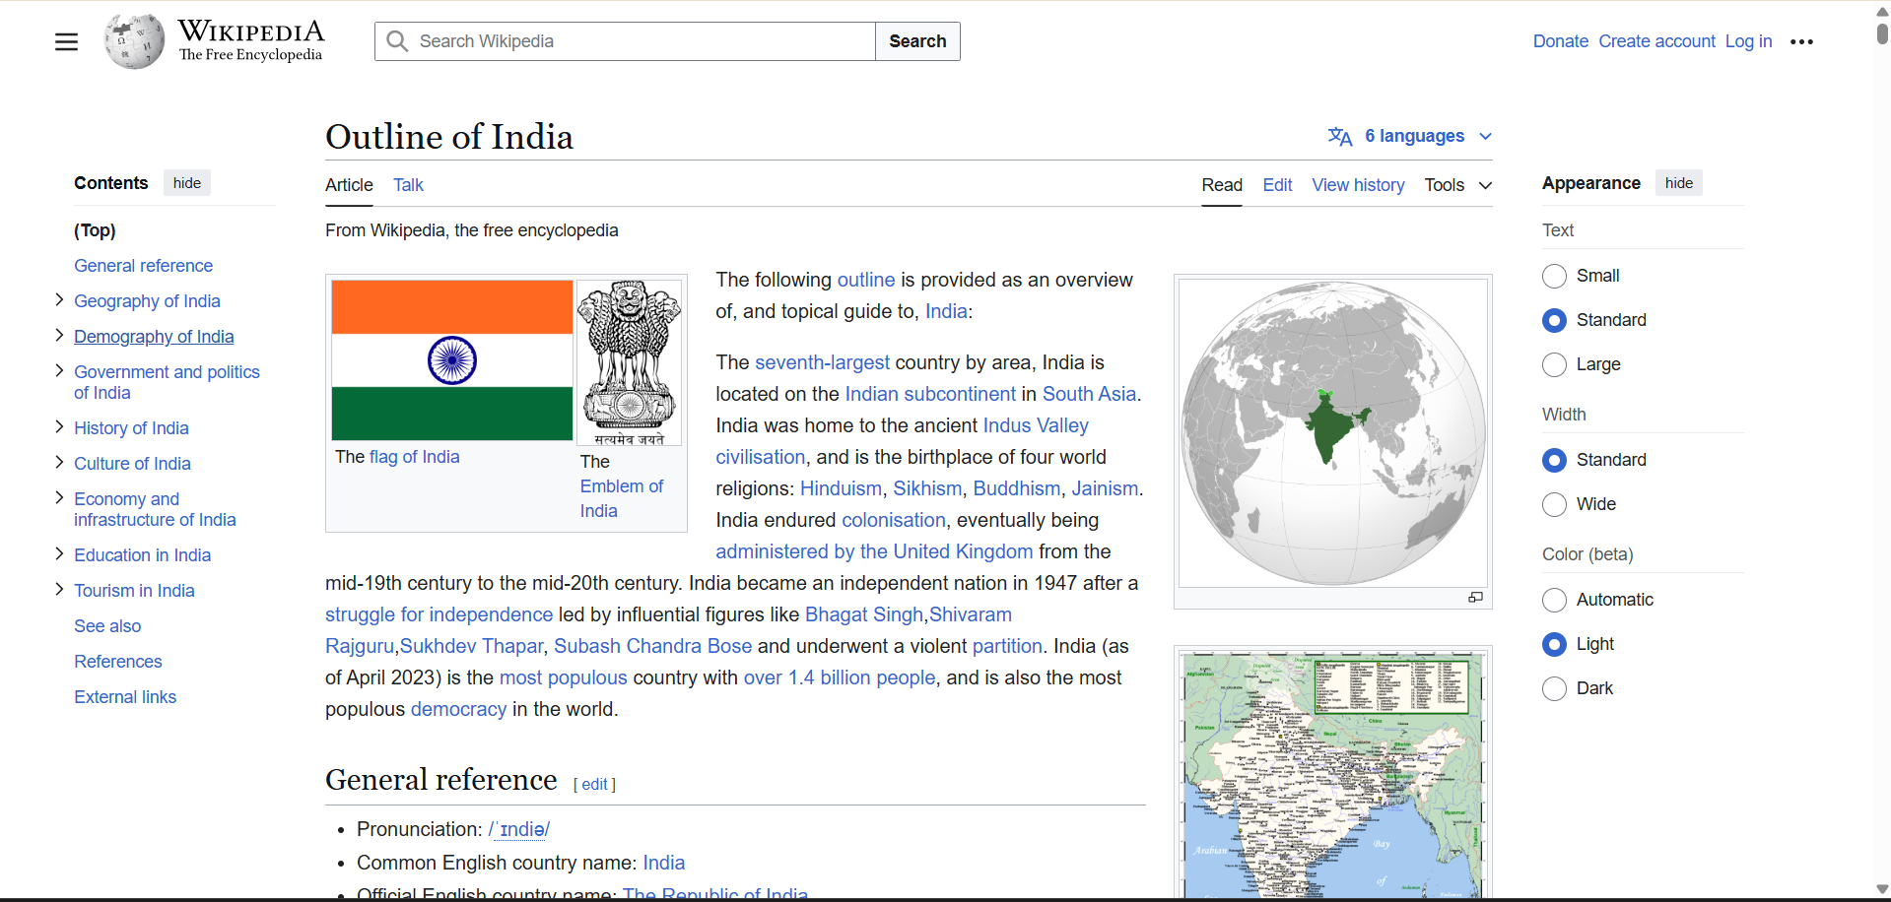

**RESULT :**Thus the experiment to create a web page that embeds a map with hotspots, frames, and links using embedded, external, and inline CSS has been successfully implemented and verified .